About GIL

STEERING ENGINEERING EXCELLENCE: GOODLUCK INDIA LIMITED (Heading)

(Highlighted Body)

**Goodluck India Limited is a leading manufacturer and supplier with over 3 decades of experience in precision engineering and steel products, catering to both domestic and international markets. Established in 1986, the company has grown steadily to become a trusted name in the steel industry, renowned for its commitment to quality, innovation, and customer satisfaction. The company is headquartered in Ghaziabad, Uttar Pradesh and boasts 6 manufacturing units situated in Sikandrabad, Uttar Pradesh and Kutch with total capacity of 4,12,000MTPA**

(BODY)

Goodluck India Limited is renowned for its robust journey from manufacturing of steel products to becoming a premier engineering solutions provider. With a legacy spanning decade, the company has navigated market shifts and technological advancements with resilience and foresight. Goodluck India Limited is not just another steel company. The company is the engineers of possibility, the shapers of precision. From the towering strength of Engineering Structures, Precision Fabrication, Forgings, Precision pipes & tubes and CR coils, all transform steel into forms that power the world. It focuses on high-margin value-added products in growth sectors such as Auto, Solar, Railways, and Defence, and is associated with prestigious programs in Defence and Aerospace. With a diverse range and customisation options, the company excels in capital and operational efficiencies. It is committed in deleveraging its balance sheet and stands out as a reliable dividend paying company. Its strong track record reflects consistent growth and progress.

Contd.

(Add Infographics) - Horizontally

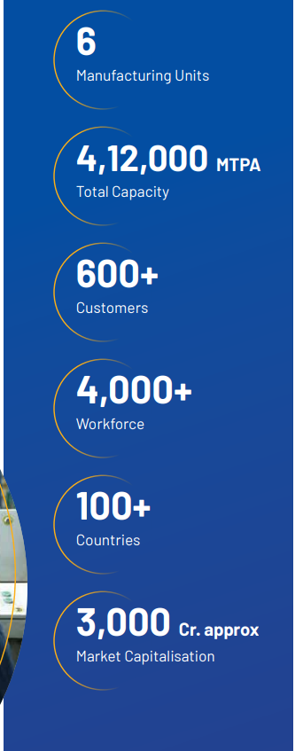

ADD Neccesary pictures throughout the Page.

**PEOPLE POWERING PROGRESS (Heading)**

**Goodluck India Limited places a strong emphasis on human resource management as a key driver of its organization excellence. The company prioritises strategic recruitment, professional development and performance enhancement to ensure that its employees are equipped to meet organizational goals. Its HR approach creates a positive work culture, encourages continuous improvement and aligns individual and team contributions with its broader business objectives.**

**(Infographic)**

1. Diversity & Inclusion
2. Talent Acquisition & Onboarding
3. Employee Development & Training
4. Employee Engagement and Well Being
5. Performance Management, Reward and Recognition
6. Occupational Health And safety

**Infographic**

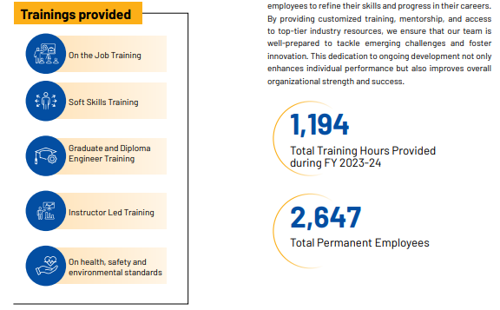

**Only Refer to the infographics above**

**Certification**

**ISO 45001: 2018**

Its approach encompasses rigorous risk assessment, extensive training, clear standards and procedures, ergonomic design, meticulous handling of hazardous materials, emergency preparedness, and health and wellness programs. It also conducts regular safety trainings, emergency mock drills, and promote ‘Near Miss’ reporting and Hazard and Operability (HAZOP) studies to further enhance workplace safety. By continuously focusing on these measures, it aims to ensure a safe work environment, minimize risks, and boost productivity.

**ENVIRONMENT STEWARDSHIP (Heading) Different Section**

Goodluck India Limited is committed in promoting sustainability and environmental stewardship through comprehensive strategies that encompasses waste management, energy efficiency and the conservation of natural resources. From adopting eco-friendly practices in manufacturing processes to engaging in focused environmental programs, Goodluck India Limited strives to set a benchmark in corporate responsibility. Through these initiatives, the company not only enhances its operational sustainability but also contributes to the broader goals of environmental preservation.

Refer to the picture below.

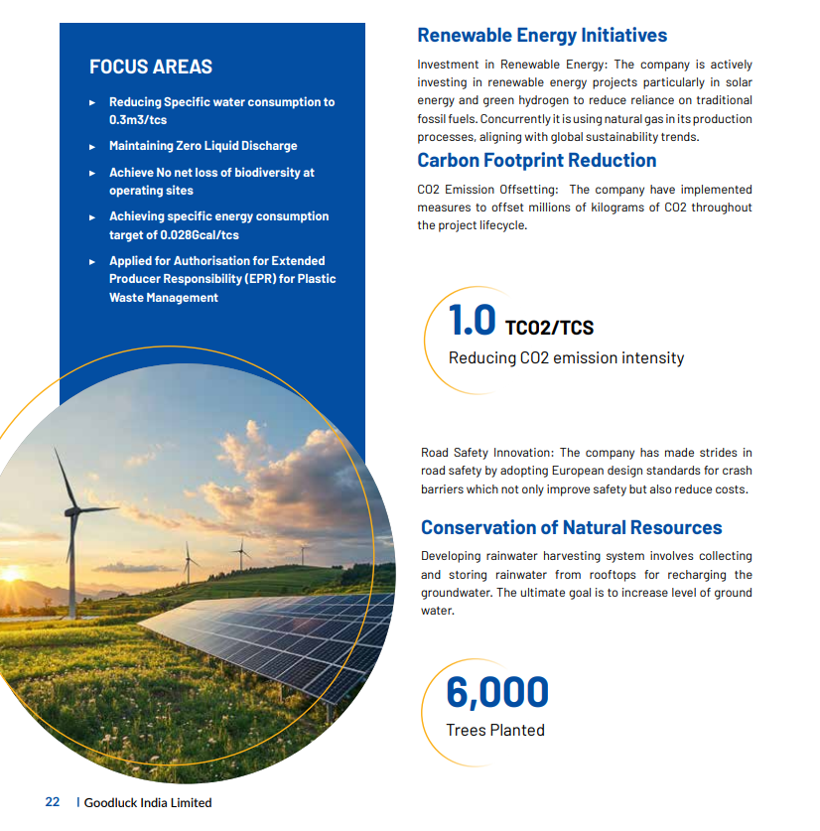

**COMMUNITY ENGAGEMENT (Heading Different Section)**

Goodluck India Limited is dedicated to make a positive impact through its diverse social initiatives. Its approach focuses on addressing critical societal needs and fostering sustainable development in the communities it serves. From advancing education and enhancing healthcare to reducing inequality, its programs are designed to create lasting benefits. By partnering with various stakeholders and investing in impactful projects, the company aims to drive meaningful change, uplift underserved populations, and contribute to the overall well-being of society. Its commitment to social responsibility reflects the company’s core values and dedication to building a better future for all.

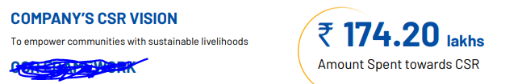

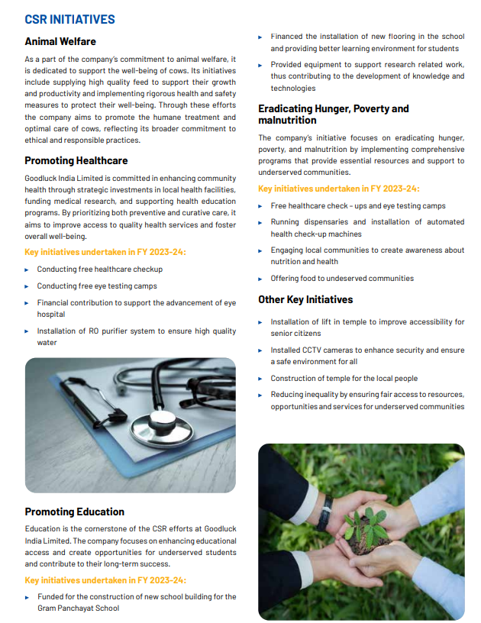

Add a new page named : Leadership Team

